**Intro to DDL, DML Commands**

_____________________________________________________________________________________________

For this lecture, we will be using **MySQL Workbench** instead of BigQuery.

What is MySQL?

MySQL is an open-source relational database management system developed by Oracle that is based on structured query language (SQL).

How to get started with MySQL - [MySQL Installation and Setup.pdf](https://drive.google.com/file/d/1gJ2W4HFY6YxYMX1xtjOyKOefW93WoO-y/view?usp=drive_link)

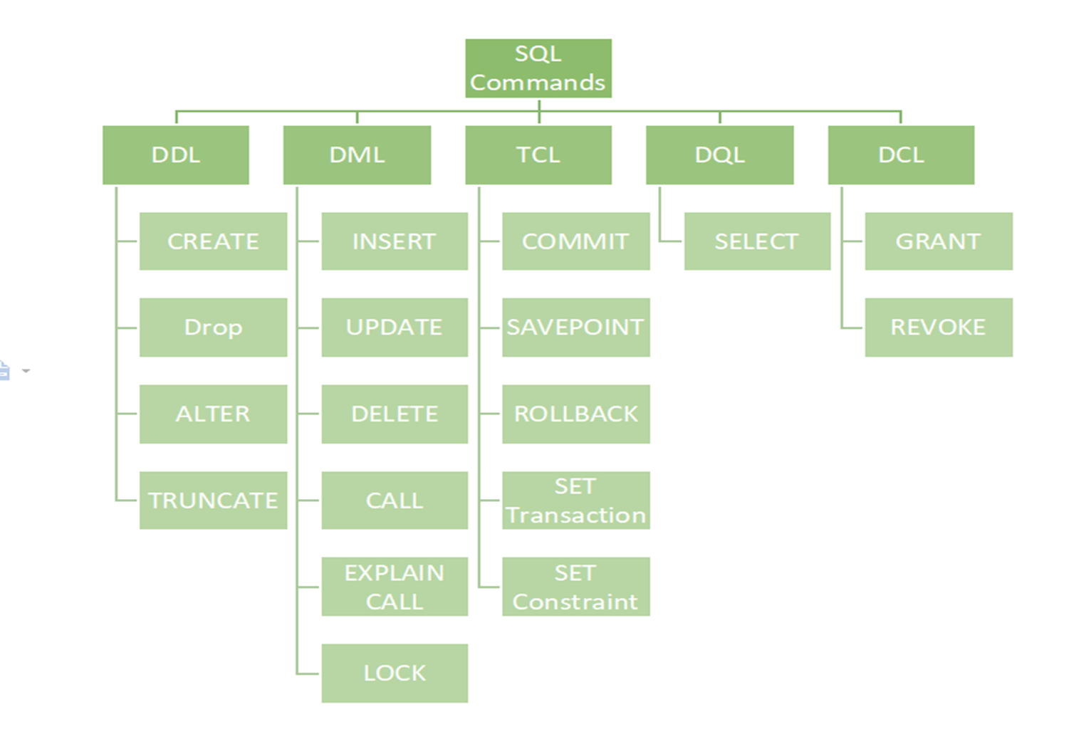

* **DDL** - Data Definition Language
* **DML** - Data Manipulation Language
* **TCL** - Transaction Control Language
* **DQL** - Data Query Language - most important
* **DCL** - Data Control Language

**What is DDL?**

* Data Definition Language (DDL) is used to define the database schema. It includes commands such as CREATE, ALTER, DROP, and TRUNCATE.

**What is DML?**

* Data Manipulation Language (DML), on the other hand, is used to manipulate data within the database. It includes commands such as SELECT, INSERT, UPDATE, and DELETE.

Let's start by discussing the **DDL commands**.

_____________________________________________________________________________________________

**CREATE command:**

The CREATE command is used to **create** a new database, table, view, or stored procedure in MySQL.

The syntax for the CREATE command is as follows:

* CREATE [DATABASE | TABLE | VIEW | PROCEDURE] object_name;

Let’s start by creating a database named “**new_db**”.

_____________________________________________________________________________________________

How to create a database in MySQL?

**Syntax:**

CREATE DATABASE database_name;

**Query:**

CREATE DATABASE new_db;

_____________________________________________________________________________________________

How to use a database in MySQL?

**Syntax:**

USE database_name;

**Query:**

USE new_db;

_____________________________________________________________________________________________

Now, let’s create a new table named ‘**customers**’.

Our table will contain the following column:

* ID
* first_name
* last_name
* age
* gender
* phone_no
* email_id
* dob
* address

**Syntax:**

CREATE TABLE table_name (

Column1 data_type <CONSTRAINT(s)>,

Column2 data_type <CONSTRAINT(s)>,

Column3 data_type <CONSTRAINT(s)>

);

**Query:**

CREATE TABLE customers (

ID INT AUTO_INCREMENT PRIMARY KEY,

first_name VARCHAR(20) NOT NULL,

last_name VARCHAR(20),

age INT CHECK(age>=18),

gender ENUM(“M”, “F”),

phone_no CHAR(10) NOT NULL UNIQUE,

email_id VARCHAR(30),

dob DATE,

address VARCHAR(100)

);

You can view the newly created “**new_db**” database and the “**customers**” table under the **SCHEMA** section in the MySQL WOrkbench.

You’ll have to click the  icon for the changes to be reflected.

_____________________________________________________________________________________________

**Constraints**

SQL constraints are used to specify rules for the data in a table.

* **UNIQUE** - Ensures that all values in a column are unique.
* **NOT NULL** - Ensures that a column cannot have a NULL value.
* **PRIMARY KEY** -
  + A combination of NOT NULL and UNIQUE.
  + Uniquely identifies each row in a table
* **FOREIGN KEY** -
  + Prevents invalid data from being inserted into the foreign key column,
  + because it has to be one of the values contained in the parent table.
* **CHECK** - Ensures that the values in a column satisfies a specific condition.
* **DEFAULT** - Sets a default value for a column if no value is specified.

_____________________________________________________________________________________________

**Data Types**

Here INT, DATE, VARCHAR, ENUM... These are all SQL data types.

They’re used to define the type of data which is stored in a column.

There are three main data types in MySQL:

1. string,
2. numeric, and
3. date & time.

You can refer to this link to showcase different MySQL data types. <https://www.w3schools.com/sql/sql_datatypes.asp>

_____________________________________________________________________________________________

**String → Char(size), Varchar(size), Enum(val1, val2, val3…)**

* **Char** is Fixed Length Character String
  + Eg. for Char(3) data type, a valid data entry could be IND, AUS, USA

Whereas inputs like INDIA, IN will throw an error.

* **Varchar** is Variable Length Character String
  + Eg. for Varchar(5) data type, a valid entry could be IN, IND, INDIA

Whereas inputs like AMERICA, AUSTRALIA will throw an error.

* **Enum** is a data type that allows you to have only one value, chosen from a list of possible values.
  + Eg. for Enum(“Yes”, “No”), valid data entries could either be or
  + If we try to insert a value which is not in the list, a blank value will be inserted.

____________________________________________________________________________________________

**Numeric → Int, Float(size, d), Bool**

* **Int** is for storing an integer value.
  + Eg. 2, 0, -10, etc.
* **Float**(size, d) is for storing a floating point number.
  + The total number of digits is specified in size.
  + The number of digits after the decimal point is specified in the d parameter.
* **Bool** is used to store a True/False value.
  + Zero is considered as false
  + Non-zero values are considered as true.

_____________________________________________________________________________________________

**Date & Time** **→ Date, Time, Datetime, Timestamp**

* **Date** data type is used for storing a date in the format YYYY-MM-DD.
  + Eg. 2023-05-17
* **Time** data type is used for storing a time in the format hh:mm:ss.
  + Eg. 03:07:00
* **Datetime** is used for storing a combination of date & time in the format YYYY-MM-DD hh:mm:ss.
  + Eg. 2023-05-17 03:07:00
* **Timestamp** values are stored as the number of seconds since the Unix epoch ('1970-01-01 00:00:00' UTC).

_____________________________________________________________________________________________

**ALTER command:**

The ALTER command is used to **modify** an existing database, table, view, or stored procedure in MySQL.

The syntax for the ALTER command is as follows:

* ALTER [DATABASE | TABLE | VIEW | PROCEDURE] object_name [modification];

The ALTER command can be used in various ways to add different modifications to our database or table.

For example,

* Adding new column(s) to a table,
* Changing the data type of a column,
* Renaming an existing column,
* Adding constraints to a column,
* Deleting a column,
* Renaming a table, etc.

_____________________________________________________________________________________________

Add a new column named ‘is_active’ to the “customers” table.

We can do this using the **ADD** keyword along with the ALTER command.

**Syntax:**

ALTER TABLE table_name

**ADD** column_name data_type CONSTRAINT(S);

**Query:**

ALTER TABLE customers

ADD is_active VARCHAR(10);

_____________________________________________________________________________________________

Change the data type of the ‘is_active’ column to INT.

We can do this using the **MODIFY** keyword along with the ALTER command.

**Syntax:**

ALTER TABLE table_name

**MODIFY** column_name new_data_type;

**Query:**

ALTER TABLE customers

MODIFY is_active INT;

_____________________________________________________________________________________________

Add constraint to the ‘is_active’ column.

We can do this using the **ADD CONSTRAINT** keyword along with the ALTER command.

**Syntax:**

ALTER TABLE table_name

**ADD CONSTRAINT** constraint_name CONSTRAINT(column1, column2…);

**Query:**

ALTER TABLE customers

ADD CONSTRAINT con CHECK(is_active IN(1,0);

_____________________________________________________________________________________________

Rename the ‘ID’ column to ‘cust_id’.

We can do this using the **RENAME** **COLUMN** keyword along with the ALTER command.

**Syntax:**

ALTER TABLE table_name

**RENAME COLUMN** old_col_name TO new_col_name;

**Query:**

ALTER TABLE customers

RENAME COLUMN ID TO cust_id;

_____________________________________________________________________________________________

Delete the ‘address’ column from the “customers” table.

We can do this using the **DROP** **COLUMN** keyword along with the ALTER command.

**Syntax:**

ALTER TABLE table_name

**DROP** **COLUMN** column_name;

**Query:**

ALTER TABLE customers

DROP COLUMN address;

_____________________________________________________________________________________________

Rename the “customers” table to “cust_info”.

**Method 1:**

We can do this using the **RENAME TO** keyword along with the ALTER command.

**Syntax:**

ALTER TABLE table_name

**RENAME TO** new_table_name;

**Query:**

ALTER TABLE customers

RENAME TO cust_info;

**Method 2:**

**Query:**

RENAME TABLE customers

TO cust_info;

**RENAME TABLE**, unlike the ALTER command, can rename multiple tables within a single statement.

**E.g.**

**RENAME TABLE**

old_table1 TO new_table1,

old_table2 TO new_table2,

old_table3 TO new_table3;

_____________________________________________________________________________________________

Now, after adding these modifications to the table, the schema for our **“cust_info”** table looks something like this…

Please note that till’ this point, we haven’t inserted a single record into our table.

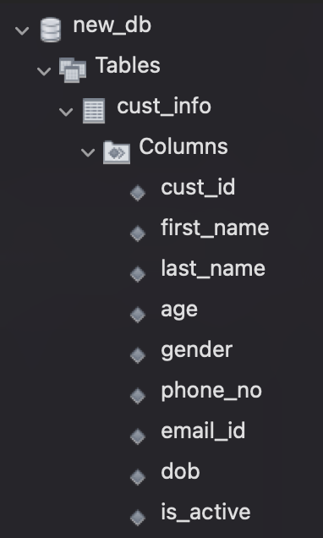

Now, let's move on to the **DML commands**.

We’ll get back to the **TRUNCATE** and **DROP** commands later.

_____________________________________________________________________________________________

**INSERT command:**

The INSERT command is used to **insert** data into a table in MySQL.

**Syntax:**

**INSERT INTO** table_name (column1, column2, ...)

**VALUES** (value1, value2, ...);

**Note:** We can omit specifying the column names if we intend to add values into all the columns present in the table.

Insert data into the “cust_info” table that we created.

**Query:**

INSERT INTO cust_info

VALUES

(101, 'John', 'Doe', 25, 'M', '8245639875', 'john@gmail.com', '1998-05-10', 1),

(102, 'Jane', 'Smith', 32, 'F', '1098476253', 'jane@gmail.com', '1991-09-22', 1),

(103, 'David', 'Johnson', 42, 'M', '7562314098', 'david@yahoo.com', '1979-07-15', 0),

(104, 'Sarah', 'Williams', 28, 'F', '3089576124', 'sarah@gmail.com', '1995-12-03', 1),

(105, 'Michael', 'Brown', 37, 'M', '9650138742', 'michael@gmail.com', '1986-03-27', 1),

(106, 'Emily', 'Davis', 29, 'F', '4721398056', 'emily@yahoo.com', '1994-11-08', 0),

(107, 'Daniel', 'Anderson', 31, 'M', '6214789305', 'daniel@gmail.com', '1992-08-19', 1),

(108, 'Olivia', 'Taylor', 24, 'F', '8356912074', 'olivia@gmail.com', '1999-02-14', 1),

(109, 'Matthew', 'Wilson', 36, 'M', '2034957168', '[matthew@gmail.com](mailto:matthew@gmail.com)', '1987-09-01', 0),

(110, 'Sophia', 'Martin', 27, 'F', '5893642701', 'sophia@yahoo.com', '1996-06-12', 1);

You can use the following query to view the data that we inserted into the “customer_info” table.

SELECT * FROM cust_info;

_____________________________________________________________________________________________

**UPDATE:**

The UPDATE command is used to **modify** existing records in a table in MySQL.

**Syntax:**

**UPDATE** table_name

**SET** column1 = value1, column2 = value2, …

WHERE condition;

For the customer having ‘cust_id’ 101, update the ‘phone_no’ to 9305884176.

**Query:**

UPDATE cust_info

SET phone_no = 9305884176

WHERE cust_id = 101;

_____________________________________________________________________________________________

**DELETE:**

The DELETE command is used to **delete** data from a table in MySQL.

**Syntax:**

**DELETE** FROM table_name

WHERE condition;

Delete the record for a customer having ‘cust_id’ as 108.

**Query:**

DELETE FROM cust_info

WHERE cust_id = 108;

_____________________________________________________________________________________________

Coming back to the DDL commands that we left earlier…

**TRUNCATE command:**

The TRUNCATE command is used to **clear** an existing table in MySQL.

The syntax for the TRUNCATE command is as follows:

* TRUNCATE TABLE table_name;

For example, if we wanted to **delete all the records** fromthe **“cust_info”** table -

**Query:**

TRUNCATE TABLE cust_info;

_____________________________________________________________________________________________

**DROP command:**

The DROP command is used to **delete** an existing database, table, view, or stored procedure in MySQL.

The syntax for the DROP command is as follows:

* DROP [DATABASE | TABLE | VIEW | PROCEDURE] object_name;

For example, to drop the **“cust_info”** table -

**Syntax:**

DROP TABLE table_name;

**Query:**

DROP TABLE cust_info;

_____________________________________________________________________________________________

**TRUNCATE vs DROP vs DELETE**

| TRUNCATE | DROP | DELETE |
| --- | --- | --- |
| It is a **DDL** command | It is a **DDL** command | It is a **DML** command |
| Used to delete all the records from a table leaving only the columns. | Used to drop a table or even a database. | Used to delete one or more specific records from a table. |
| **TRUNCATE** TABLE table_name; | **DROP** TABLE table_name; | **DELETE** FROM table_name WHERE condition; |